**<Data Science Toolbox: Python Programming>**

**PROJECT REPORT**

(Project Semester January-April 2025)

***(Candy Distributor Sales)***

Submitted by

Pradeep Jampana

Registration No 12307758

Programme and Section – B. Tech CSE, K23GX

Course Code INT-375

Under the Guidance of

**Name of faculty:** Gargi Sharma

**UID:** 29439

**Discipline of CSE/IT**

**Lovely School of Computer Science**

**Lovely Professional University, Phagwara**

**CERTIFICATE**

This is to certify that Pradeep Jampana bearing Registration no. 12307758 has completed INT 375 project titled, **“Marketing Campaign Results”** under my guidance and supervision. To the best of my knowledge, the present work is the result of his/her original development, effort and study.

**Signature and Name of the Supervisor**

**Designation of the Supervisor**

**School of …………………………………………….**

Lovely Professional University

Phagwara, Punjab.

Date: 12-04-2025

**DECLARATION**

I, Pradeep Jampana, student of Computer Science under CSE/IT Discipline at, Lovely Professional University, Punjab, hereby declare that all the information furnished in this project report is based on my own intensive work and is genuine.

Date: 12-04-2025 Signature

Registration No. 12307758 J. Pradeep

1. **Problem Statement:**
2. To understand the distribution of customer demographics such as age and gender by analysing the data from the provided Excel sheet. The goal is to identify dominant age groups and gender ratios to tailor marketing strategies accordingly.
3. To classify customers into meaningful segments based on characteristics like age, gender, and income. This helps in personalizing marketing campaigns and allocating resources to the most responsive customer groups.
4. To evaluate how customers responded to a marketing campaign by analysing the Campaign_Response data. This analysis will provide insights into the success rate of the campaign and inform future marketing decisions.
5. To identify patterns in customer behaviour by examining demographic and transactional variables like age, income, and marketing engagement. The aim is to build a predictive model or derive rules to forecast customer churn or responses to campaigns.
6. To determine how marketing budget is being utilized across different marketing channels and to identify which channels are yielding better returns. This helps in reallocating the budget for maximum efficiency.
7. Datasetlink: <https://app.mavenanalytics.io/datasets?search=Marketing+Campaign+Results>
8. **Implementation: -**

**Objective 1:** To understand the distribution of customer demographics such as age and gender by analysing the data from the provided Excel sheet. The goal is to identify dominant age groups and gender ratios to tailor marketing strategies accordingly.

**Purpose:** To identify target groups based on age and gender that can help in designing more personalized and effective marketing strategies.

**Approach**: Load customer data from the Excel file, use histograms to analyse age distribution. Use count plots to visualize gender distribution.

**Outcome:** Identify most common age brackets, Determine gender ratio (e.g., male vs female customers).

**Code:**

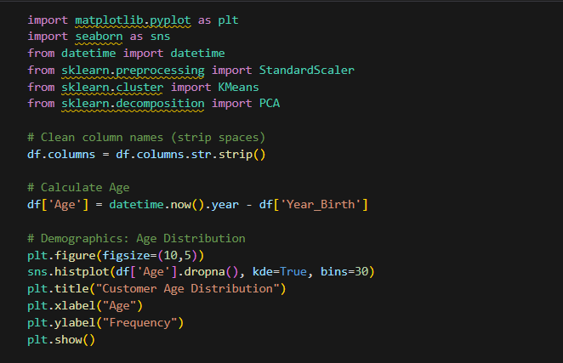

**Output:**

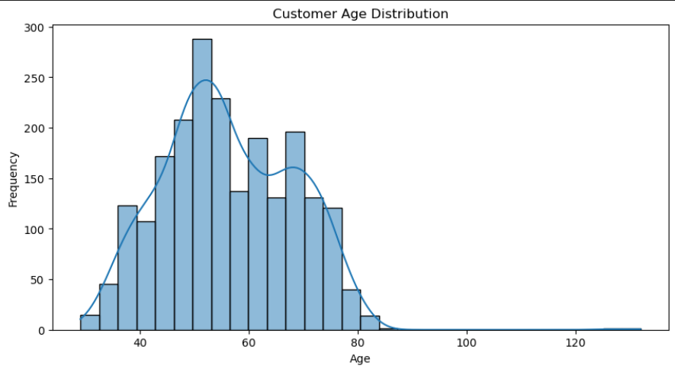

**Objective 2:** To classify customers into meaningful segments based on characteristics like age, gender, and income. This helps in personalizing marketing campaigns and allocating resources to the most responsive customer groups.

**Purpose:** To categorize customers into meaningful groups based on demographics or spending patterns for better marketing effectiveness.

**Approach:** Use scatter plots for Age vs Income to visually observe clusters, optionally apply K-Means clustering (advanced) to form segments. Label or tag segments based on visual patterns or rules

**Outcome:** Discover high-income or high-potential customers, Segment customers for personalized ads or offers.

•

**Code:**

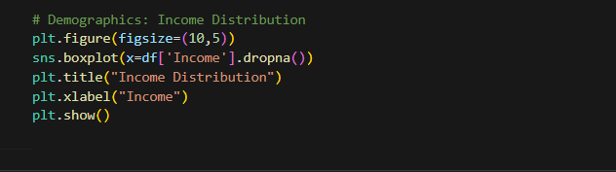

**Output:**

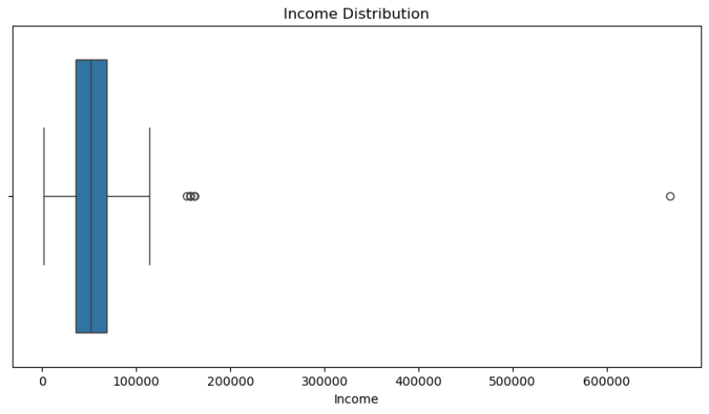

**Objective 3:** To evaluate how customers responded to a marketing campaign by analysing the Campaign_Response data. This analysis will provide insights into the success rate of the campaign and inform future marketing decisions.

**Purpose:** To evaluate how successful a recent marketing campaign was in terms of customer engagement or response.

**Approach:** Analyse the Campaign_Response column, Plot count plots to show how many responded positively vs negatively, Compare responses across demographics (optional cross-analysis).

**Outcome:** Determine overall response rate, Identify demographics with higher response.

**Code:**

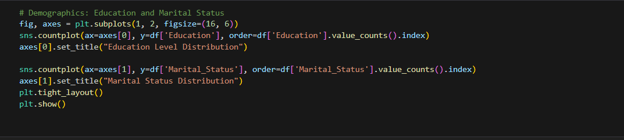

**Output:**

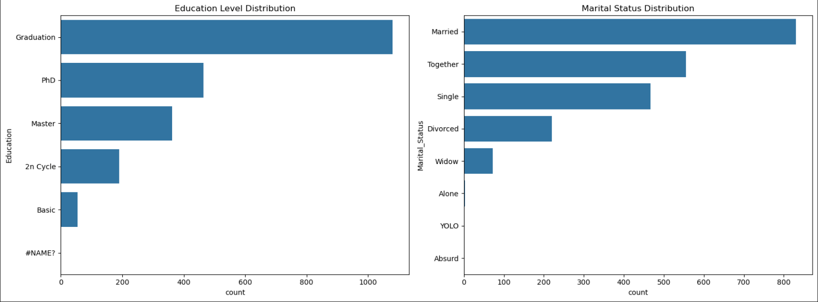

**Objective 4:** To identify patterns in customer behaviour by examining demographic and transactional variables like age, income, and marketing engagement. The aim is to build a predictive model or derive rules to forecast customer churn or responses to campaigns.

**Purpose:** To analyse current patterns in customer data to predict future behaviour like churn, upsell potential, or campaign engagement.

**Approach:** Explore relationships between Age, Income, and Campaign Response, use visualizations (scatter plots, heatmaps) for trends, optionally build a model (logistic regression, decision trees) for prediction.

**Outcome:** Spot customers likely to respond or churn, create a predictive model for future behaviour, Support strategic planning and customer retention.

**Code:**

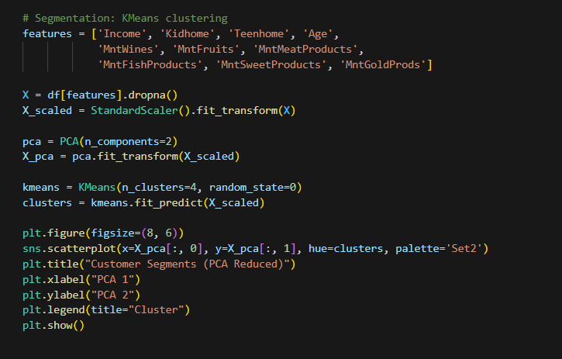

**Output:**

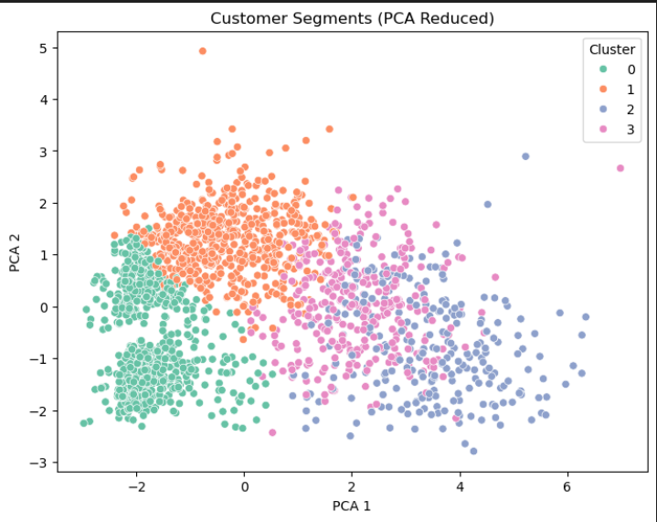

**Objective 5:** To determine how marketing budget is being utilized across different marketing channels and to identify which channels are yielding better returns. This helps in reallocating the budget for maximum efficiency.

**Purpose:** To evaluate how funds are distributed across marketing channels and identify which channels yield better returns.

**Approach:** Analyse Spend against Marketing_Channel, use bar plots to show comparative spending, Investigate ROI per channel (if revenue or response data is available).

**Outcome:** Find underperforming or overperforming channels, Make informed budget allocation decisions, Maximize return on marketing investment.

**Code:**

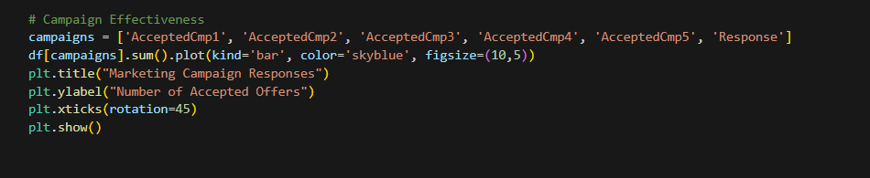

**Output:**

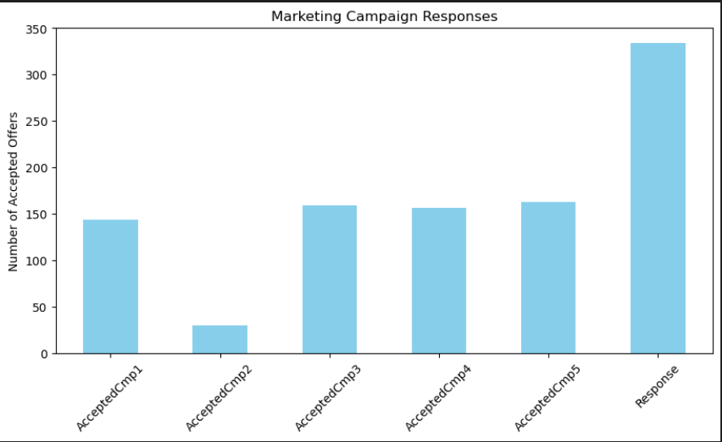

**Code:**

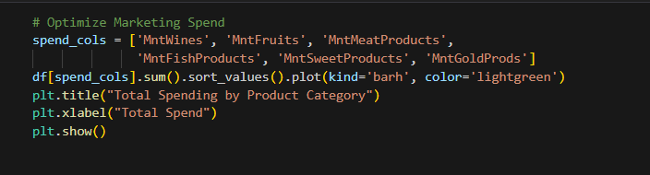

**Output:**

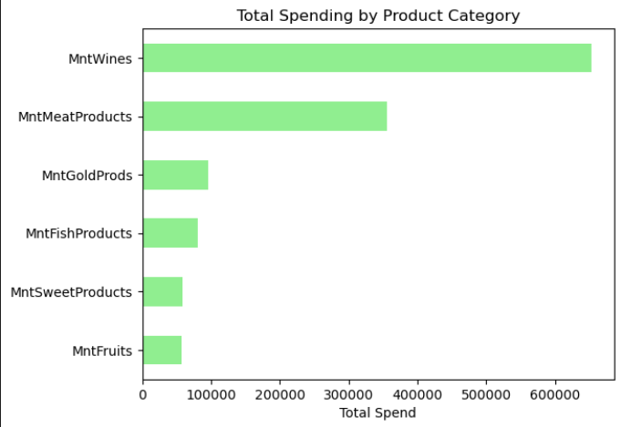

**LinkedIn:**

[**https://www.linkedin.com/posts/jampana-pradeep-6b993235b_datascience-dataanalysis-datascientist-activity-7316778330693795841-Ppk4?utm_source=share&utm_medium=member_desktop&rcm=ACoAAFmpIG0B_6RKn9a4pkO2uU-spIScbjhgLzY**](https://www.linkedin.com/posts/jampana-pradeep-6b993235b_datascience-dataanalysis-datascientist-activity-7316778330693795841-Ppk4?utm_source=share&utm_medium=member_desktop&rcm=ACoAAFmpIG0B_6RKn9a4pkO2uU-spIScbjhgLzY)

**GitHub:**